**LRD** is the estimated distance at which a point can be found by its neighbors. It also tells us the density of a point.

It’s the inverse of average reachability distance of point from it’s neighbors.

In below image it’s equation is given, where we are first taking sum of reach-dist of each point with neighbourhood of xi and then we are dividing it by total no. of point in neighbourhood of xi**.** So basically we are taking average of reach-dist.

And then we take inverse of this reach-dist.

Note: |N(xi)| need not to be equal to k in k-NN. As suppose for k=1, there are more than 1 nearest points at same distance.

E.g: Let’s say K=1 and the distance form x_i to it’s 1st NN is 10 units. If two points lie exactly at 10 units distance from x_i, then, |N(x_i)| = 2 as we have two-points within the neighborhood constructed using the distance to 1-NN.

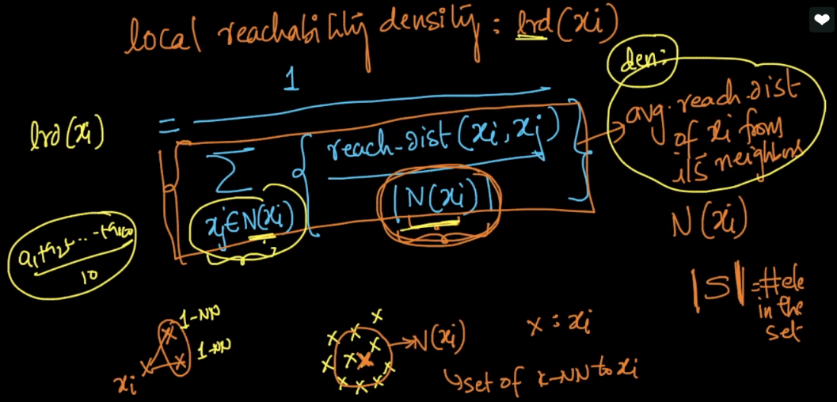

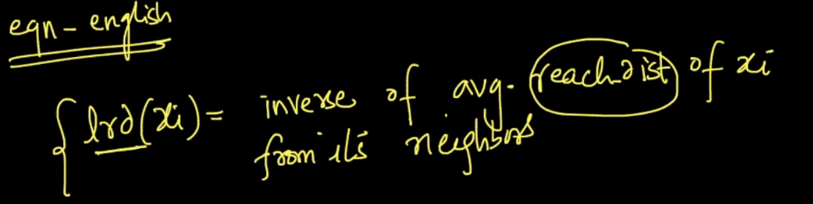

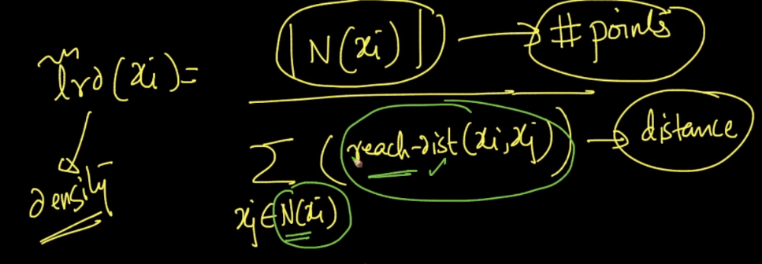

**Example:**

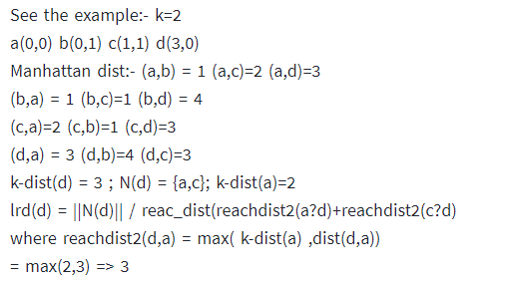

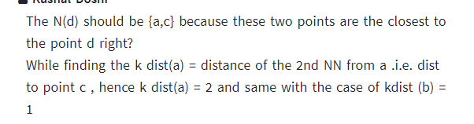

**Comments:**

* Suppose if I am working on a problem using KNN with k=1 and suppose we have 2 points equidistant from xq, so, if we consider |N(x)| =2 then, in the reachability section of the formula, do we consider both equidistant neighbors or just 1 of them??

Basically we chose either of the two when we have equidistant neighbors.

distance a,b,c from d : d->a = 3 ; d->b=4 ; d->c=3 so Kth NN for k=2 in case of d => a,c since both are of same distance i.e, 3 here so in that case we can chose either of them for the kth nearest neighbor.

For more details must read: [**https://medium.com/@mtngt/local-outlier-factor-example-by-hand-b57cedb10bd1**](https://medium.com/@mtngt/local-outlier-factor-example-by-hand-b57cedb10bd1)